Database Lab Evaluation

Tarun Gothwal

Batch A

1. Display the last name and salary for all employees whose salary is not in the range of 5,000 and 12,000.

Ans. Select last_name,salary from employees

where salary not between 5000 and 12000;

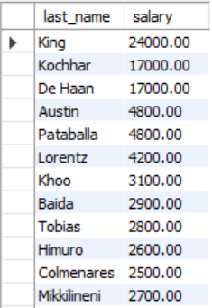

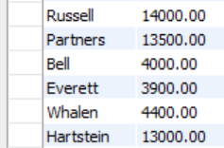

1. Display the employee last name, job ID, and start date of employees hired between February 20, 1998, and May 1, 1998.

Ans. Select last_name,job_id,hire_date from employees

where hire_date between '1998-02-20' and '1998-05-01'

order by hire_date;

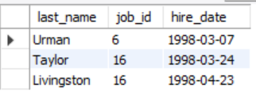

1. Display the last name and department number of all employees in departments 20 and 50 in alphabetical order by name.

Ans. select last_name,department_id from employees

where department_id=2 or department_id=5

order by last_name;

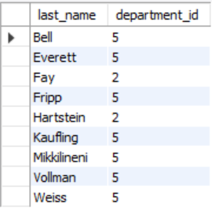

1. Display the employee last name and employee number along with their manager’s last name and manager number. Label the columns Employee, Emp#, Manager, and Mgr#, respectively.

Ans. SELECT e.last_name "Employee", e.employee_id "EMP#",

m.last_name "Manager", m.employee_id "Mgr#"

FROM employees e join employees m ON (e.manager_id = m.employee_id);

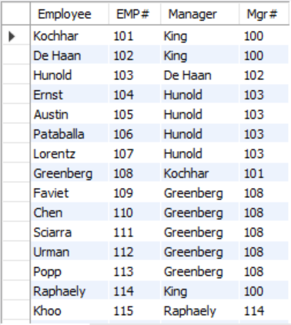

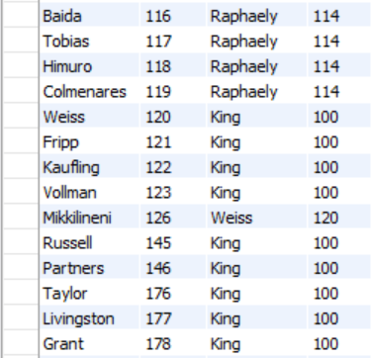

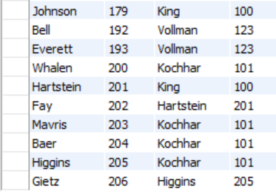

1. Create a query that displays employee last names, department numbers, and all the employees who work in the same department as a given employee. Give each column an appropriate label.

Ans. SELECT e.department_id department, e.last_name employee, c.last_name colleague FROM

employees e JOIN employees c

ON (e.department_id = c.department_id) WHERE e.employee_id <> c.employee_id

ORDER BY e.department_id, e.last_name, c.last_name;

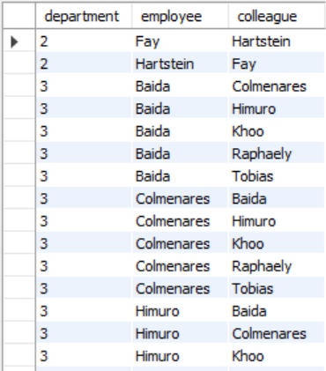

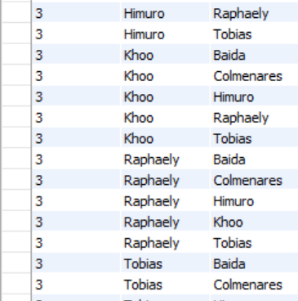

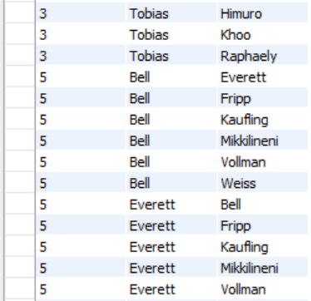

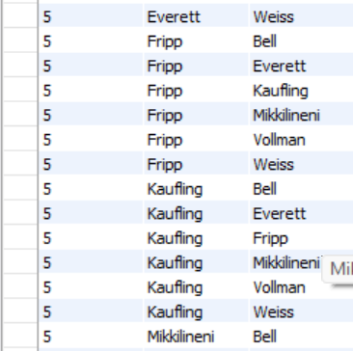

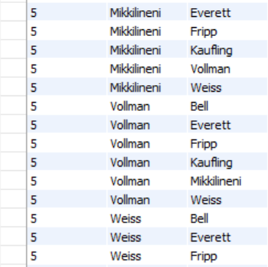

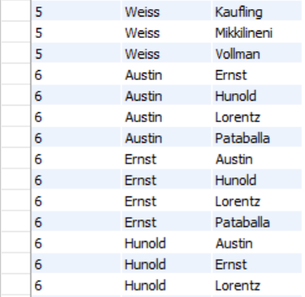

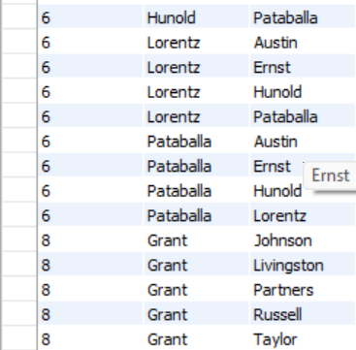

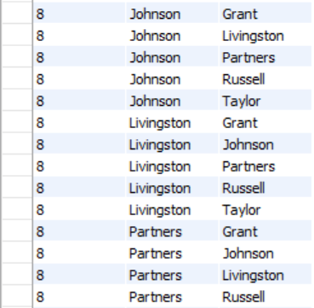

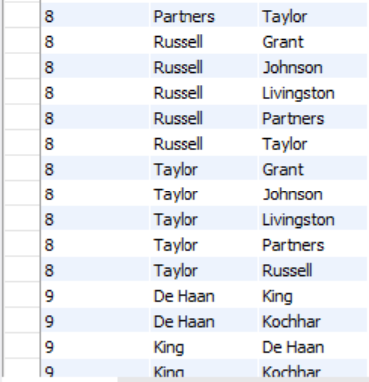

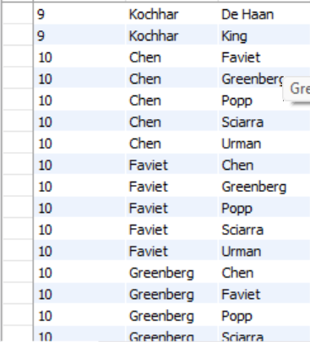

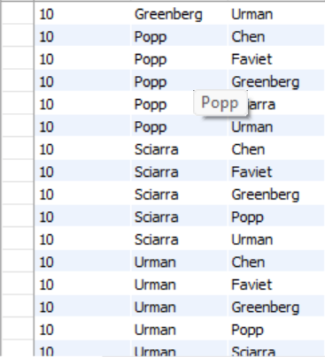



1. Create a query that displays employee last names, job title, and city of all the employees who work in the same city as a given employee. Give each column an appropriate label.

Ans. SELECT e.last_name, l.city, j.job_title

FROM employees e, departments d, locations l, jobs j

WHERE e.department_id = d.department_id

AND

d.location_id = l.location_id;

1. Display the names of all employees who earn less than the average salary in the company.

Ans. SELECT first_name, last_name, salary

FROM employees WHERE salary < (SELECT AVG(salary) FROM employees );

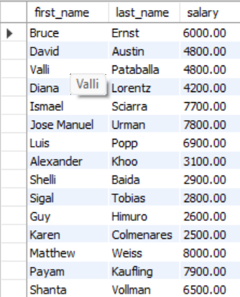

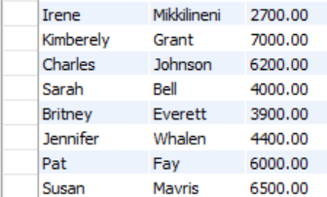

1. Display employees who are not IT programmer and whose salary is more than any of the IT-programmer.

Ans. select employees.last_name,employees.salary,

employees.job_id,jobs.job_title as "Job"

from employees natural join jobs

WHERE job_id NOT IN (9)

AND salary > ('IT_PROG');

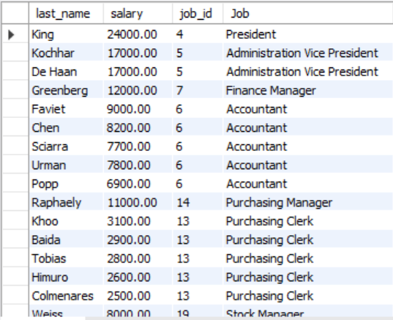

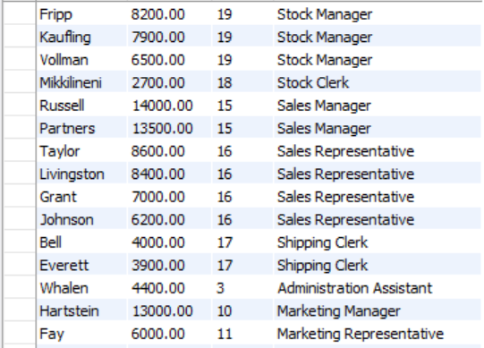

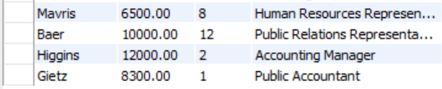

1. Display the name of the employee with highest salary

Ans. select first_name,last_name,max(salary) from employees;

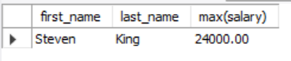

1. Display the employee last names, salaries, department numbers, and average salaries for all the employees who earn more than the average salary in their department.

Ans. SELECT first_name, last_name, salary, department_id

FROM employees

WHERE salary >

(SELECT AVG (salary)

FROM employees);

